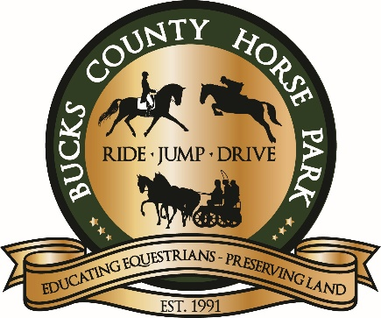
2025 In-Gate Eventing
Entry Form

(Not for use for USEA/USDF or Schooling Horse Trials)
Mail to: BCHP, P.O. Box 386, Revere, PA 18953
Email: administrator@buckscountyhorsepark.org Phone: 610-847-8597 ~ Fax: 610-847-5507
Date: ______________ Dressage Only Test:_____________________
XC Level (circle): Intro Starter Elementary BN Novice
Stadium Level (circle): Intro Starter Elementary BN Novice
Rider: | DOB: | BCHP #:
Horse: | Age: | Height:
Email:
Address:
Phone:
Emergency Contact #:

Please review the official prizelist for all rules/regulations and information. All changes are at management discretion. Release: I understand that horse sports may be hazardous and dangerous, even leading to permanent injury or death, and I assume any and all risk of loss or injury to myself, my animals and equipment, etc. and agree to hold harmless, regardless of negligent acts or omissions, Bucks County, the Bucks County Horse Park, organizers, show committee, all horse show personnel, and volunteers. YOU ASSUME THE RISK OF EQUINE ACTIVITIES PURSUANT TO PENNSYLVANIA LAW.

____________________________ ___________________________
Signature of Competitor Date Signature of Parent/Guardian Date
Dressage only: $30 XC Round: $20 EACH
Stadium Round: $15 EACH Fix-A-Test: $90
Full Horse Trial: $70
Release_____ Coggins ______ Payment_______ CC or Check

